**Orange Coding Academy Bootcamp**

**Application Name: Farm**

**Name: Esraa Alkhalilah**

[1.Summary](https://www.fao.org/3/w7365e/w7365e05.htm#2.1.2%20definition)

[2.Introduction](https://www.fao.org/3/w7365e/w7365e05.htm#2.1.2%20definition)  
 [3.User Authorization](https://www.fao.org/3/w7365e/w7365e05.htm#2.1.3%20optimization)    
 [4. Admin](https://www.fao.org/3/w7365e/w7365e05.htm#2.1.4%20objectives)   
 [4.1 farms](https://www.fao.org/3/w7365e/w7365e05.htm#2.1.5%20economics%20as%20the%20framework%20for%20farm%20system%20analysis)

[4.2 news](https://www.fao.org/3/w7365e/w7365e05.htm#2.1.5%20economics%20as%20the%20framework%20for%20farm%20system%20analysis)

[4.3 users](https://www.fao.org/3/w7365e/w7365e05.htm#2.1.5%20economics%20as%20the%20framework%20for%20farm%20system%20analysis)   
 [5. Technologies](https://www.fao.org/3/w7365e/w7365e05.htm#2.1.6%20alternative%20bases%20for%20farm%20system%20analysis)

[5.1 frontend](https://www.fao.org/3/w7365e/w7365e05.htm#2.1.5%20economics%20as%20the%20framework%20for%20farm%20system%20analysis)

[5.2 backend](https://www.fao.org/3/w7365e/w7365e05.htm#2.1.5%20economics%20as%20the%20framework%20for%20farm%20system%20analysis)   
 [6.Farm Website](https://www.fao.org/3/w7365e/w7365e05.htm#2.1.7%20farm%20management%20fields)

[6.1 Home](https://www.fao.org/3/w7365e/w7365e05.htm#2.1.5%20economics%20as%20the%20framework%20for%20farm%20system%20analysis)

[6.2 About](https://www.fao.org/3/w7365e/w7365e05.htm#2.1.5%20economics%20as%20the%20framework%20for%20farm%20system%20analysis)

[6.3 Contact](https://www.fao.org/3/w7365e/w7365e05.htm#2.1.5%20economics%20as%20the%20framework%20for%20farm%20system%20analysis)

[6.2 Filter](https://www.fao.org/3/w7365e/w7365e05.htm#2.1.5%20economics%20as%20the%20framework%20for%20farm%20system%20analysis)

**1.Summary**

my application talk about how to organize the booking farm because recently we show a lot of people how to book farms and still on day or more in this farm so I put in my application every farm and filter like price

In this site the user can create farm and booking farm and this site have admin dashboard .

**2.Introduction**

Recently, Web Application is an essential part for all business issues or any project you would to apply in real world you need to schedule or manage it and the best choice is create web application which contain all details and features you need to do with to make your life easier and faster. So, here we can see the responsibility of Web Application developers to make people’s issues easier to handle, so my application to easer booking farm and find any farm you need also you can filter farms through price, location ,space.

**3. User Authorization and Authentication**

There is a special part of authorization for user in this application, as we know the main target in all projects is the user and his satisfaction of the application for that reason you can find bellow all permissions that can user have in this application.

**1.1 Permissions:**

1. Create account:

User can first create his own account with full validation system to ensure that user used a valid information that has assigned in code before, during user insertion will read error messages to tell him the correct data needed to complete him account creation. For sure all information which belongs to users are saved in encrypted way for his security and satisfaction.

After user create his account can then login to the website and then start his journey in booking.

1. Login:

In this step will authenticate the user and ensure if this user has created his account or not, so if this user is really exit in database the application will take him to the home page and his name will appear first

then he can move through all pages in the web application and choice any product and add it to the cart.

3. Booking and checkout process:

The user can shop and move through all products and choose any farm want after than can checkout and ensure the order by fill all required details.

All these info about user location and order details are submitted to the admin who responsible for that.

4. logout: the user after finish all website service can logout.

5. Edit profile: the user can edit profile like change password or username or email .

Register: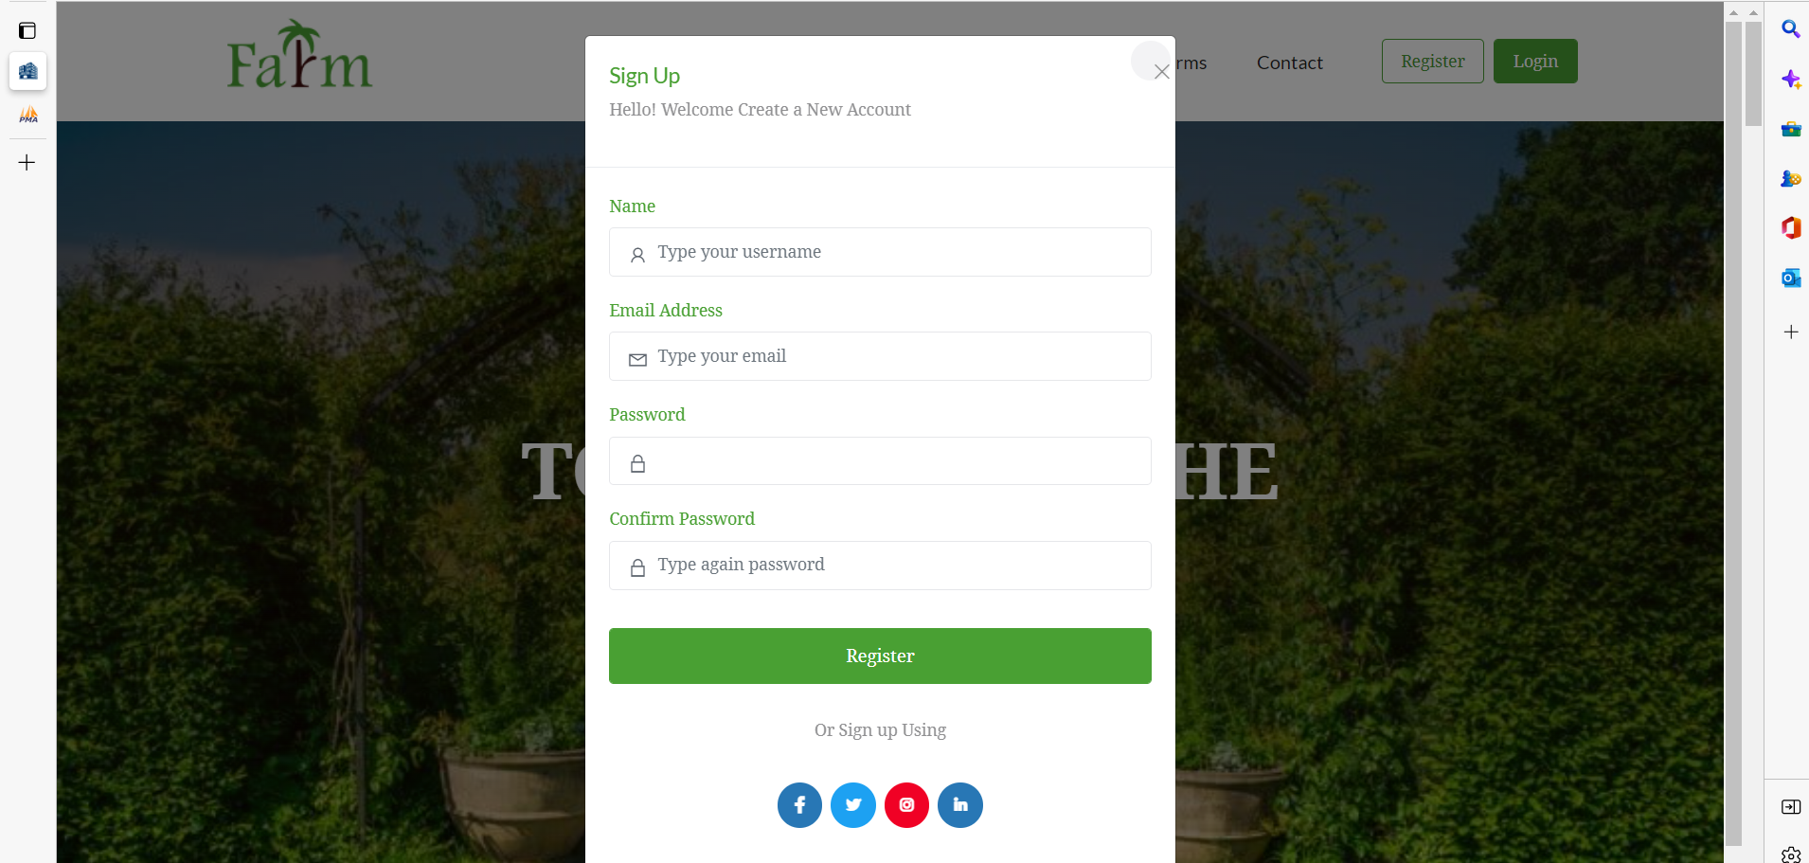

Login:

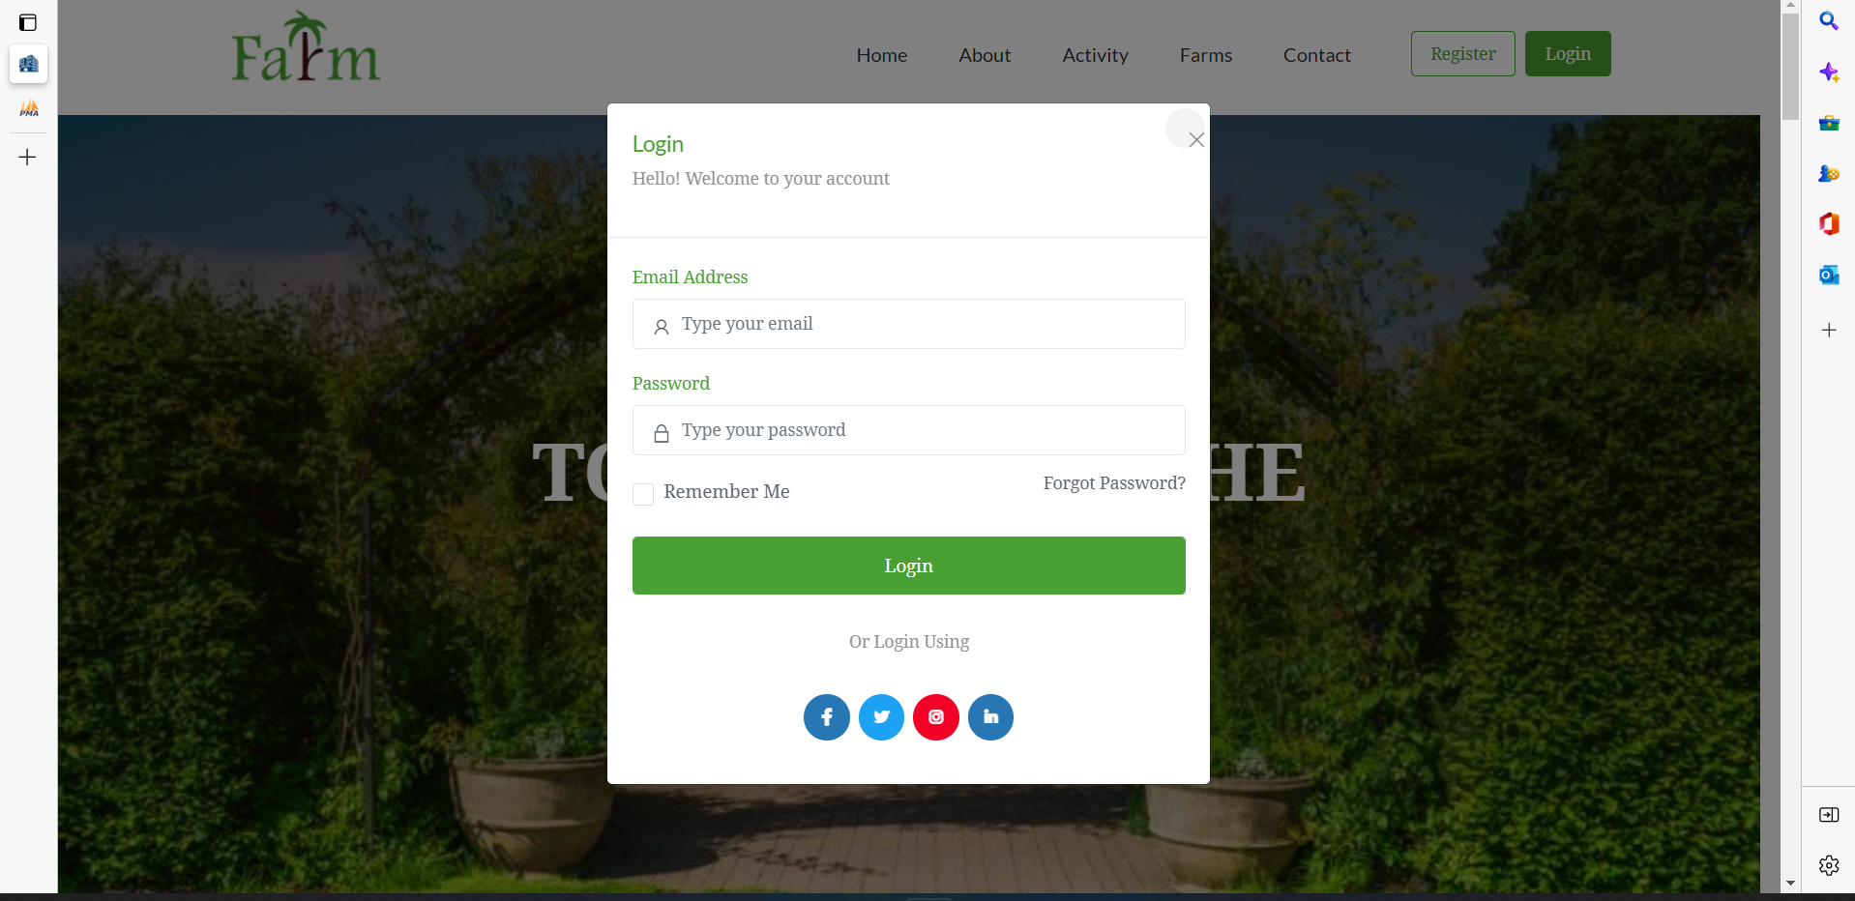

User Table :

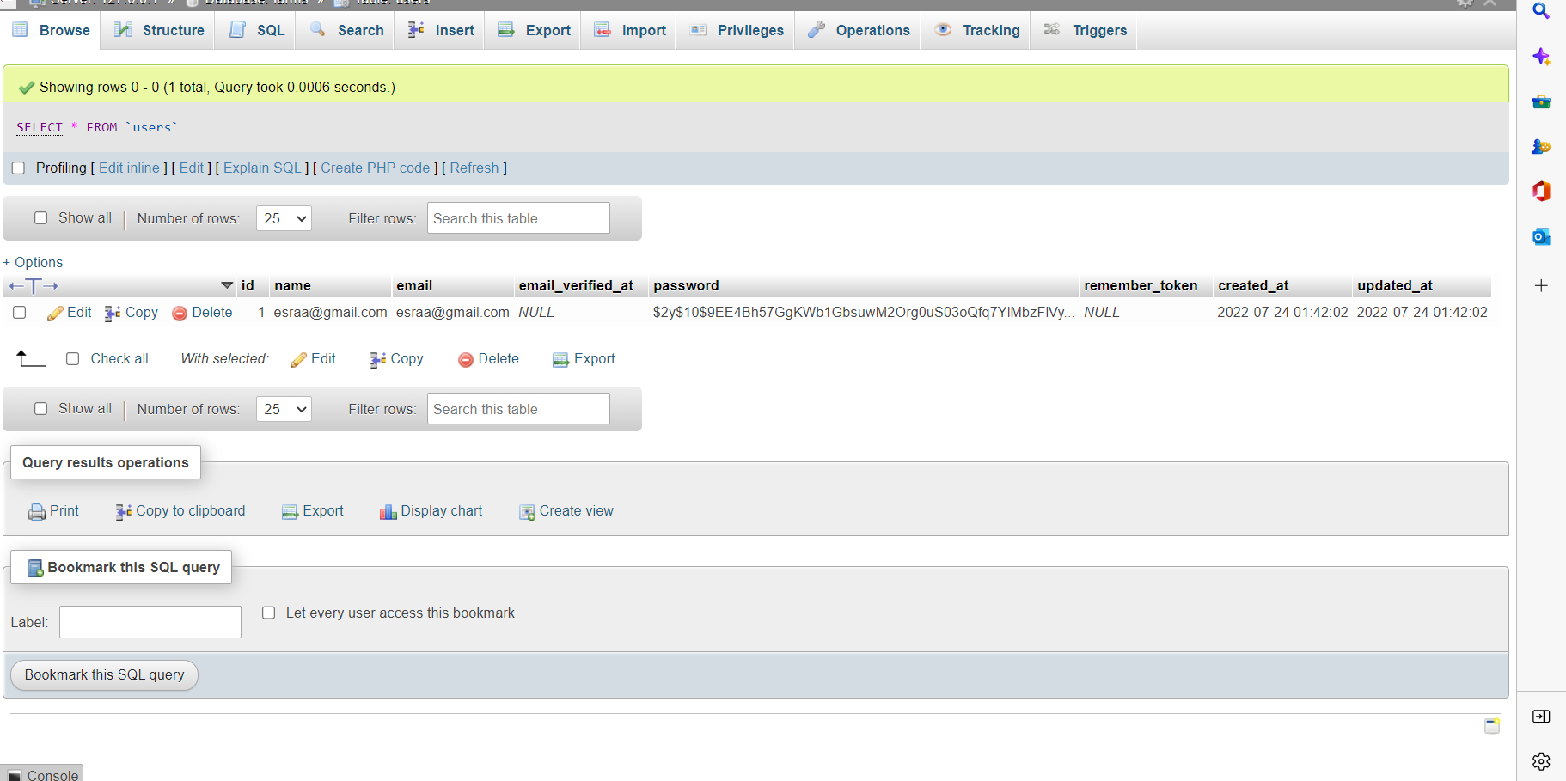

**4. Admin capabilities**

**4.1 farms:**

1. Add:

Admin can add a new farm with all required details and accept farm from user if it is existed such as: name, brief, date, day, image, description.

1. Update:

Admin can update any farm all details and submit it after finish editing and this feature is essential in admin part so he can manage anything related to the farms.

1. Delete: Admin can delete any farm and this action will appear in admin UI and in database as we suppose that admin have an access to the database.
   1. **News:**
2. Add:

Admin can add a new news with all required details such as: name, brief, picture, summary.

1. Update:

Admin can update any new all details and submit it after finish editing and this feature is essential in admin part so he can manage anything related to the news.

1. Delete: Admin can delete any new and this action will appear in admin UI and in database as we suppose that admin have an access to the database.
   1. **user:**

1- Delete: Admin can delete any user and this action will appear in admin UI and in database as we suppose that admin have an access to the database.

* 1. **Member:**

1-Add:

Admin can add a new member with all required details such as: name, brief, picture, summary.

2-Update:

Admin can update any member all details and submit it after finish editing and this feature is essential in admin part so he can manage anything related to the members.

3-Delete: Admin can delete any member and this action will appear in admin UI and in database as we suppose that admin have an access to the database.

**5- Technologies**

**5.1 Frontend:**

**HTML:** is the universal markup language for the Web. HTML lets you format text, add graphics, create links, input forms, frames and tables, etc., and save it all in a text file that any browser can read and display.

**CSS:** CSS stands for Cascading Style Sheets. It is a language designed to specify the overall appearance of webpages as well as the appearance and structure of the text and elements such as images and buttons on webpages and their layout. Styles can be specified with CSS using internal style sheet definitions which are placed right into HTML/XHTML code or in external files.

**Java Script:** JavaScript is a multi-paradigm, dynamic language with types and operators, standard built-in objects, and methods. Its syntax is based on the Java and C languages — many structures from those languages apply to JavaScript as well. JavaScript supports object-oriented programming with object prototypes, instead of classes

**5.2** **Backend:**

**PHP:** PHP is a server-side scripting language that is embedded in HTML. It is used to manage dynamic content, databases, session tracking, even build entire e-commerce sites.

It is integrated with a number of popular databases, including MySQL, PostgreSQL, Oracle, Sybase, Informix, and Microsoft SQL Server.

**SQL:** which stands for **Structured Query Language** is a language to manage and communicate with databases. For instance, it is used for database creation, deletion, update rows by fetching rows, modifying rows, etc. SQL statements are used for tasks like updating data on a database or retrieving data from a database.

**Laravel:** PHP framework contains MVC patterns, model controller and view addition route and can make migration to generate database .

**6. website**

* 1. **Home:**

Contains navbar, slider, the best farms then some activity in farm after that questions section from user about website how to work or about how to booking, feedback sections also the last news abouts farm and footer.

* 1. **About us:**

Contains paragraph about our website, our team then gallery contain some picture from beautiful farms finally history about our website.

* 1. **Contact Us**

User can send message and contact with us if face any problem or if have any suggestion to improve our website also contains all information about us like email ,phone number and location.

**Home:**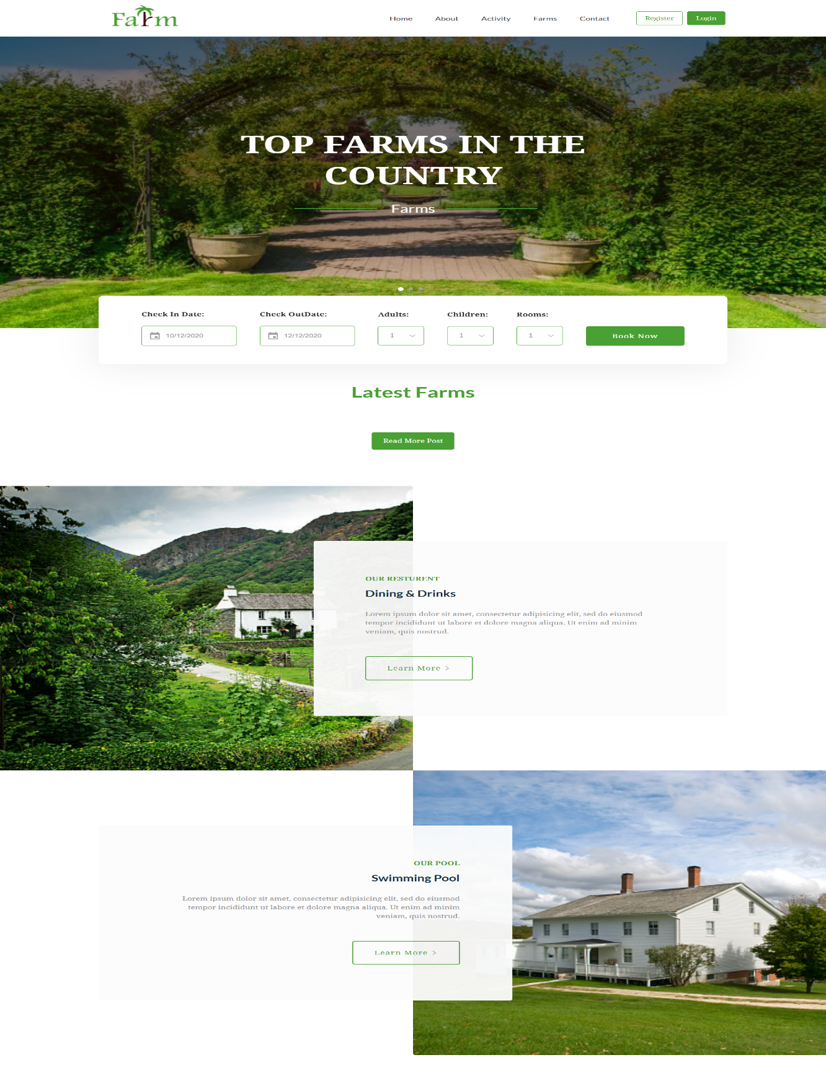

$Home:$ 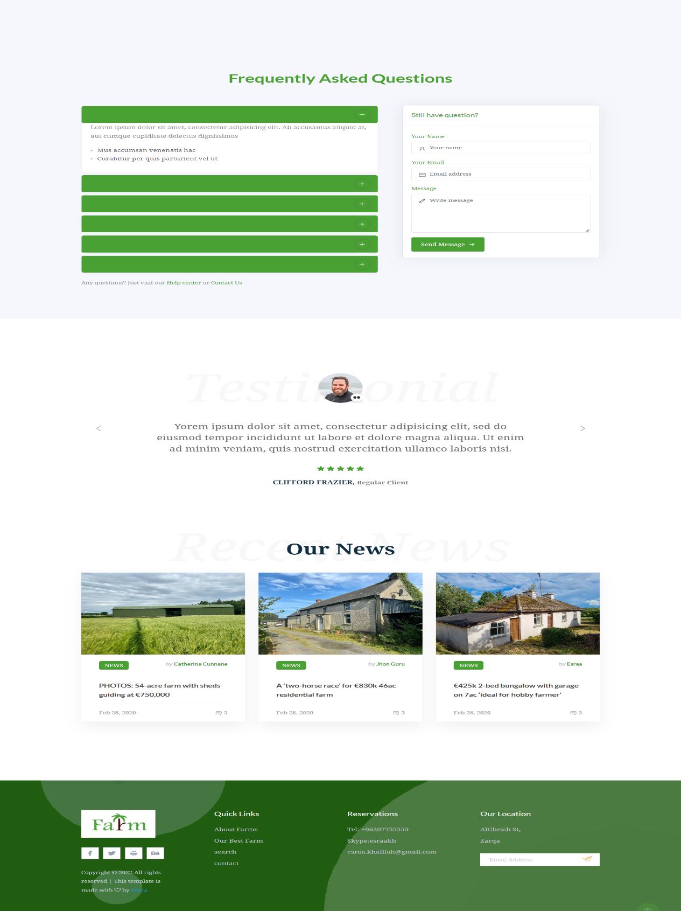

**Abou Us:**

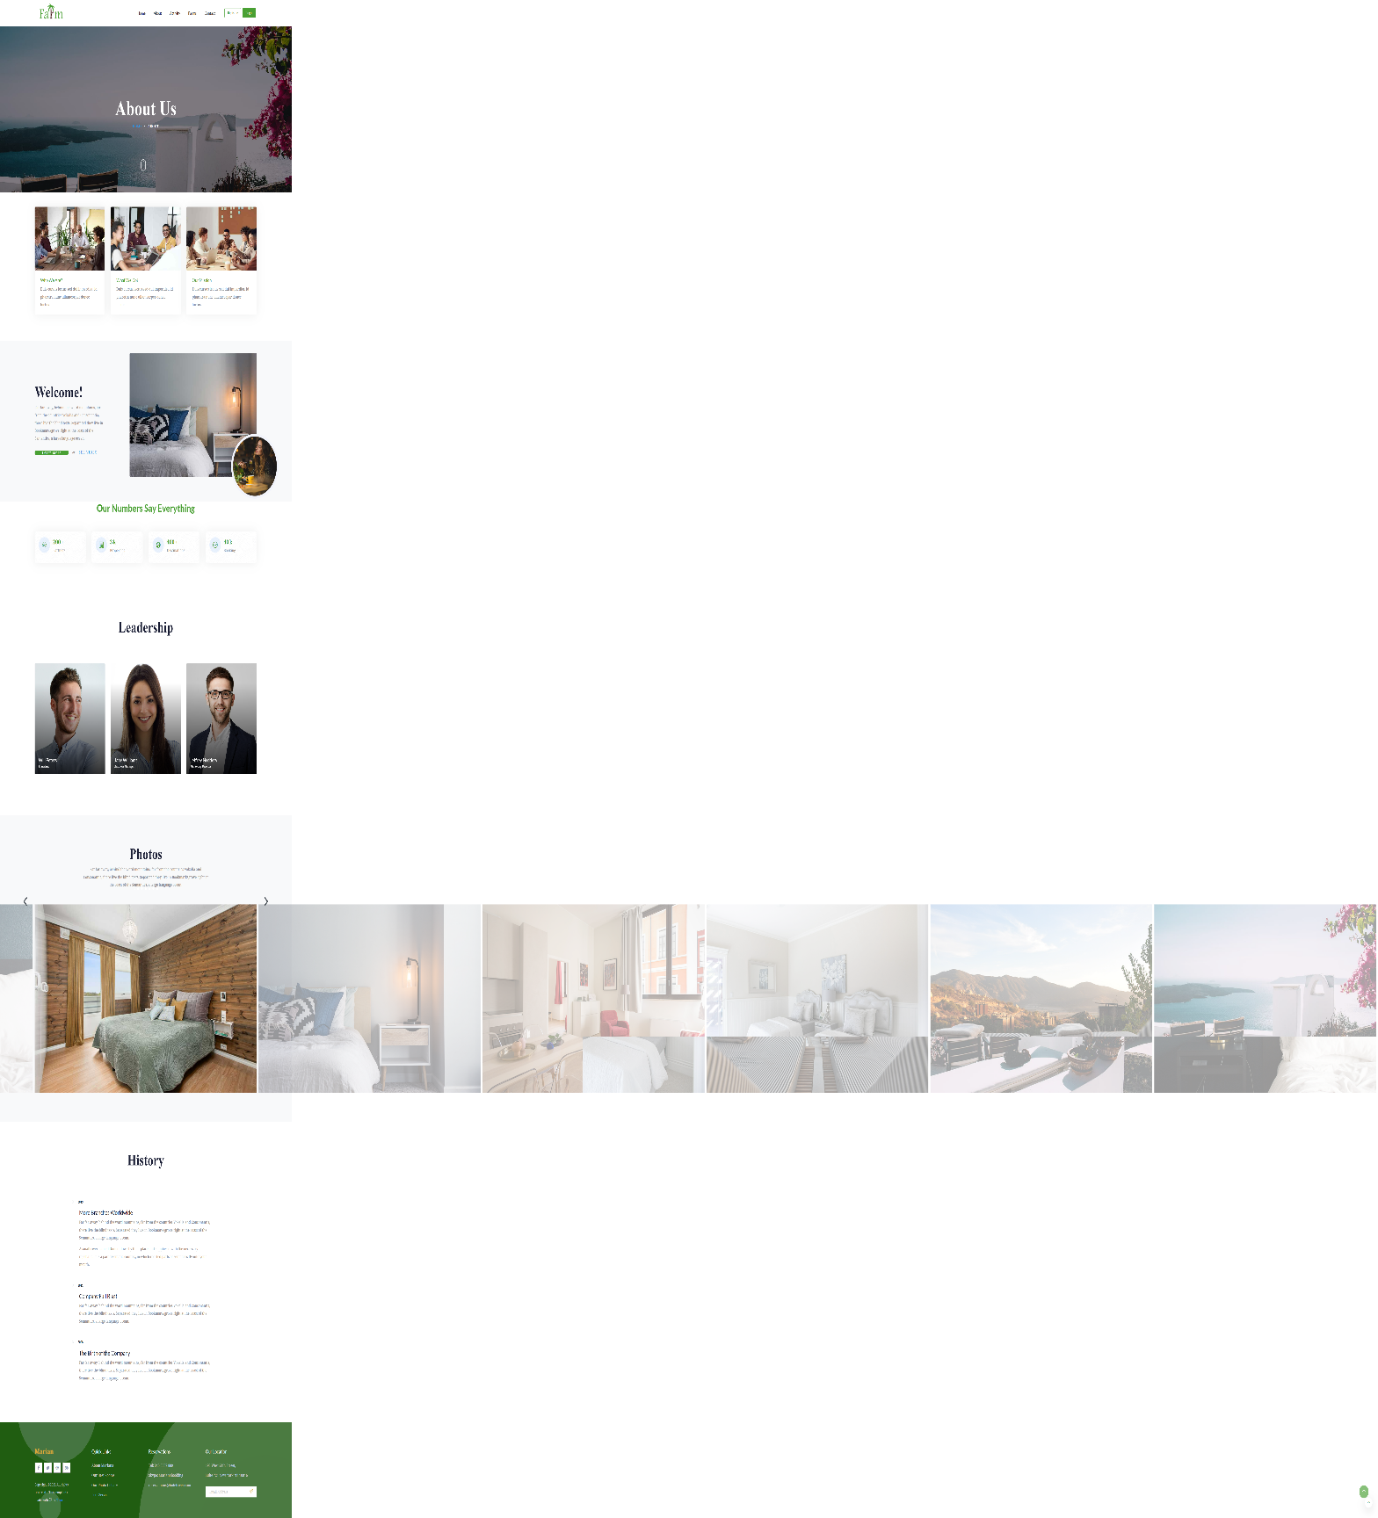

**Contact Us:**

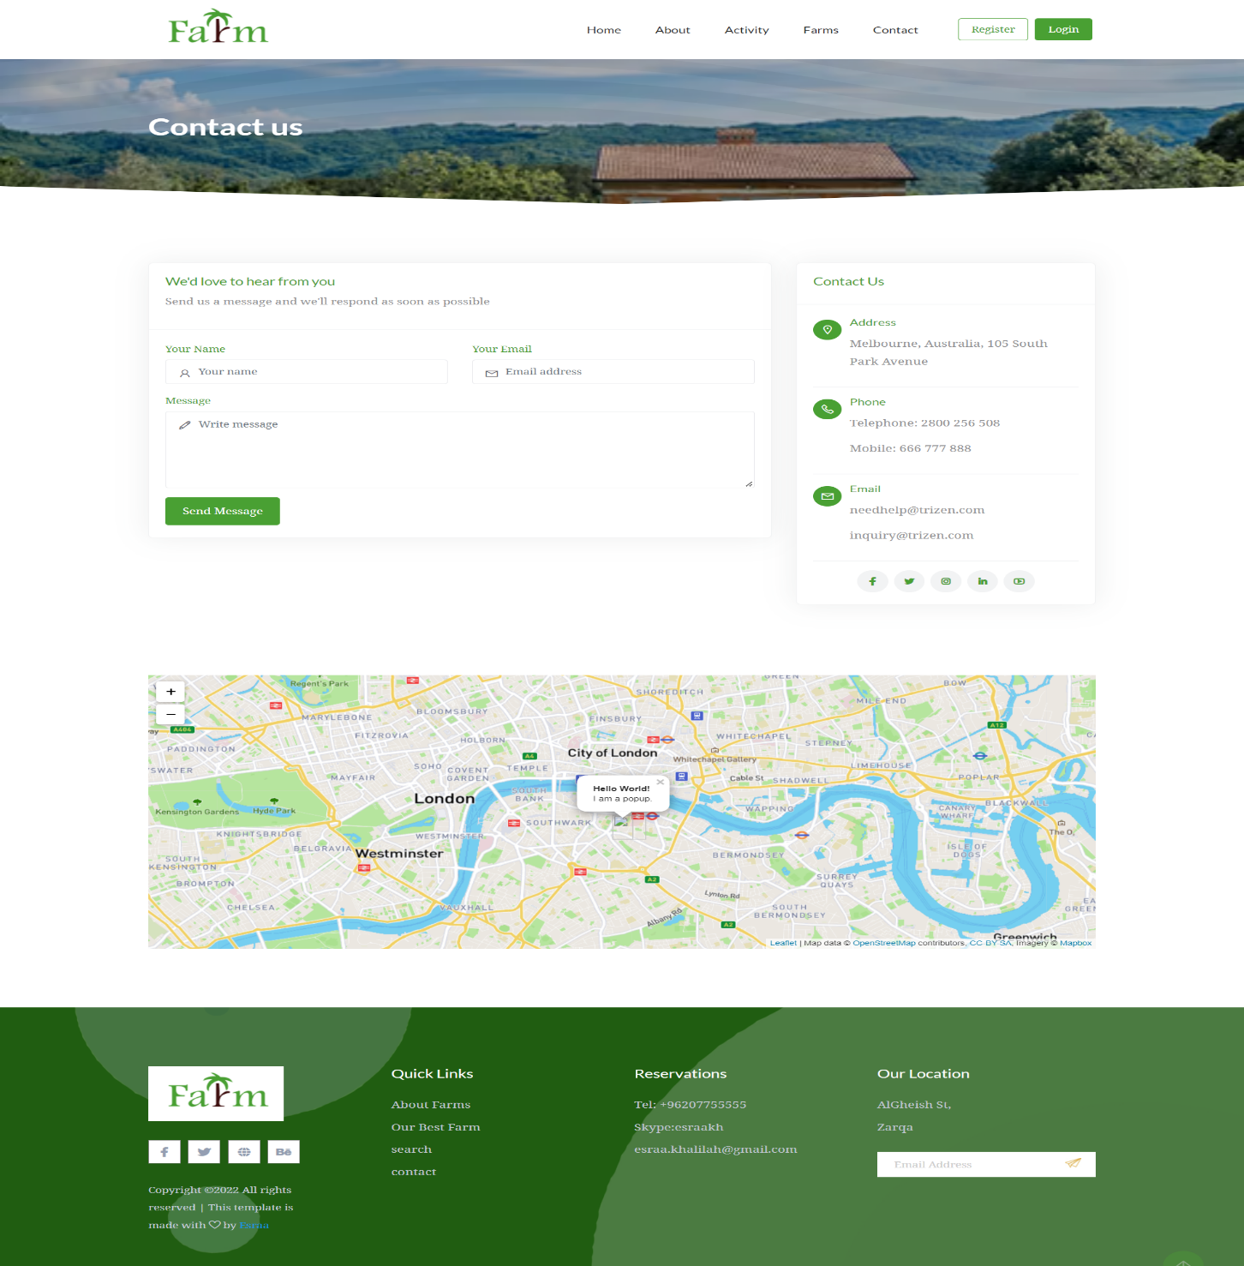

* 1. **Filter**

This page the user can filter farms to price that’s mean cheap or expensive, location in any city space the farm that’s mean big or small, number rooms in farm and activity in this farm like pool.

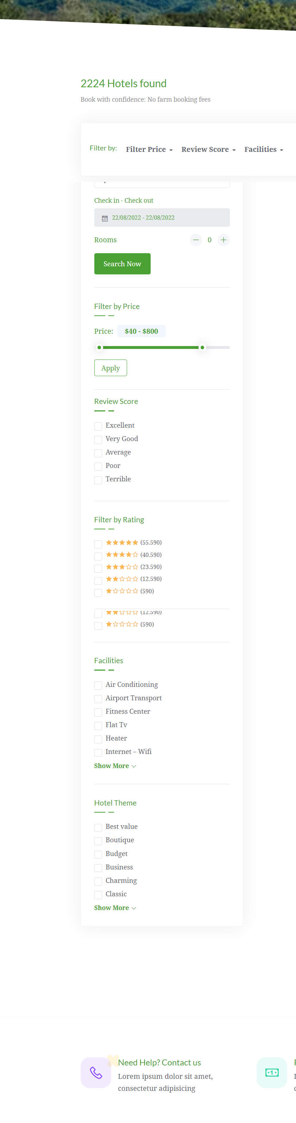

* 1. **questions**

This page the user can ask any question about website or about booking and how to use our website and show all important questions from all user.

